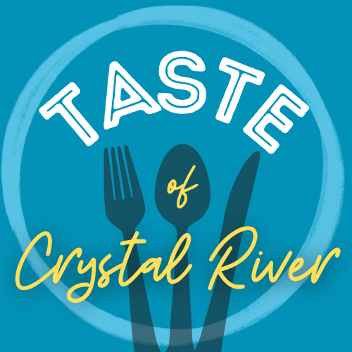

Crystal River Main Street is excited to host the 2nd Taste of Crystal River! This signature fundraising event will take place on Friday October 21 at the Crystal River Town Square. The event will feature tasting plates from participating restaurants, live entertainment and beer & wine sales. Events of this magnitude can only be successful with the help of gracious business sponsors like you. If you have any questions regarding the event, please reach out to Meredith Linley at 352-212-4077 or meredith@crystalrivermainstreet.com

Sponsorship Levels
Presenting Sponsor (One) - $2500
Exclusive named sponsor – “Taste of Crystal River presented by Your Business Name”
Named in all marketing materials and on tickets themselves
10 VIP tickets including open bar (beer and wine) (value $750)
Banner placement at event
Reserved seating at event
Multiple commercials from stage throughout the evening
Social Media posts on Crystal River Main Street page as well as on the Taste of Crystal River event page

Gold Sponsor - $1000
Logo on marketing materials
Banner placement at event
Reserved seating at event
4 general admission event tickets &2 VIP tickets (value $350)
Social Media posts on Crystal River Main Street page as well as on the Taste of Crystal River event page

Silver Sponsor - $500
Reserved seating at event
Named in marketing materials
2 VIP tickets ($150 value)
Social Media posts on Crystal River Main Street page as well as on the Taste of Crystal River event page

Bronze Sponsor - $250
2 general admission event tickets
Social Media posts on Crystal River Main Street page as well as on the Taste of Crystal River event page

